**ISNVD Annual Meeting 2015 – Save the Date**

**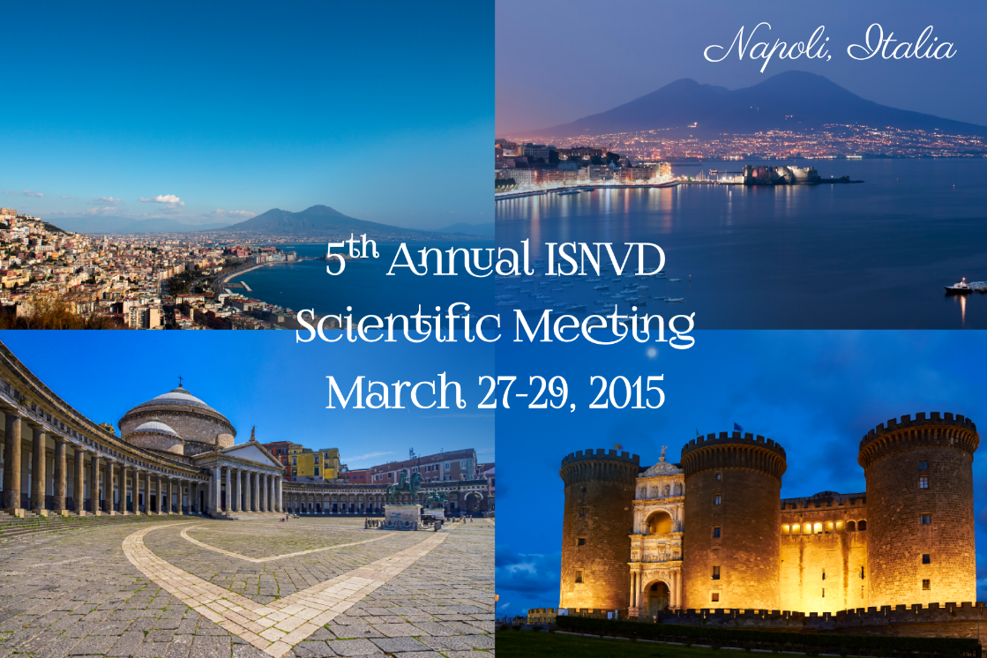  
(Contact information:** [**info@isnvd.org**](mailto:info@isnvd.org)**,** [**mpcongressi@gmail.com**](mailto:mpcongressi@gmail.com) **or** [**kdenz@isnvd.org**](mailto:kdenz@isnvd.org)**)**

The International Society for Neurovascular Disease is very pleased to announce that our 2015 Annual Meeting will be held on March 27th – 29th in Naples, Italy.  We are really hoping that you will be able to join us as this will prove to be a most interesting event as well as educational opportunity.

Join your friends and colleagues at this year’s meeting venue which will be the Congress Centre Federico II – Partenope which is located on the seafront of Naples in the central area, panoramic and close to the best hotels in town.  This will be an excellent net-working opportunity for you.

We have confirmed many well-known, international speakers that represent specialties such as Neurology, Radiology and Neurosurgery that will be presenting.  The discussions will focus on the diagnosing of neurovascular disorders as well as the treatment of neurological disease.

The congress venue as well as hotel information are currently posted on our website.  Please visit [www.isnvd.org](http://www.isnvd.org/) for the most current, up-to-date congress information.  Here, you can also view the official program agenda as well as information about Naples, the conference venue as well as area attractions.

•        **Note:  Registration opening and Call for Abstracts will be posted in the very near future as well as communicated to you.**

***This year, we are able to offer:***

**Four Sessions:**

**1.**         **Hemodynamics of the Brain**

**2.**        **Quantitative flow and computational fluid modeling**

**3.**        **Venous dysfunction and treatment strategies**

**4.**        **Endothelial function, glymphatic system and new drug development**

**Two Satellite Courses:**

**a.**        **Ultrasound Imaging**

**b.**        **MRI**

**Key-note lecture:**

***"The Heart-brain Axis: An Overlooked Cause of Brain Aging."***  
**Professor Mat Daemen,  
University of Amsterdam  
Amsterdam, The Netherlands**